How to access the AADE webinar and obtain your credit(s):
- Go to www.diabeteseducator.org
- Click the gray ‘Sign In’ box near the upper right corner of the page
- Select the “My Learning” option from the dropdown
- Login, or if you are new to AADE, sign-up.

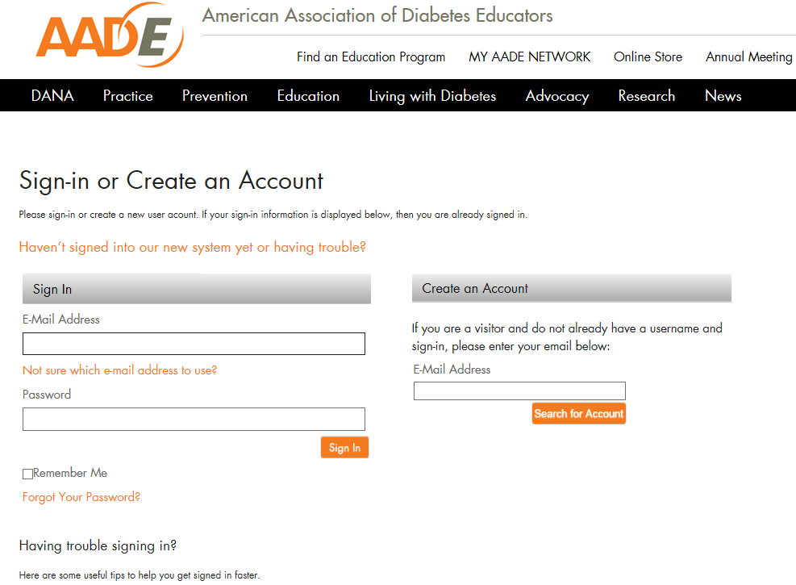
4

- You will be directed to the AADE “My Online Learning” portal, click the “My learning” tab in the upper left corner of the page.
- Scroll down to the bottom of that page, and in the bottom-right corner, submit the GE code: XP9LRXCT

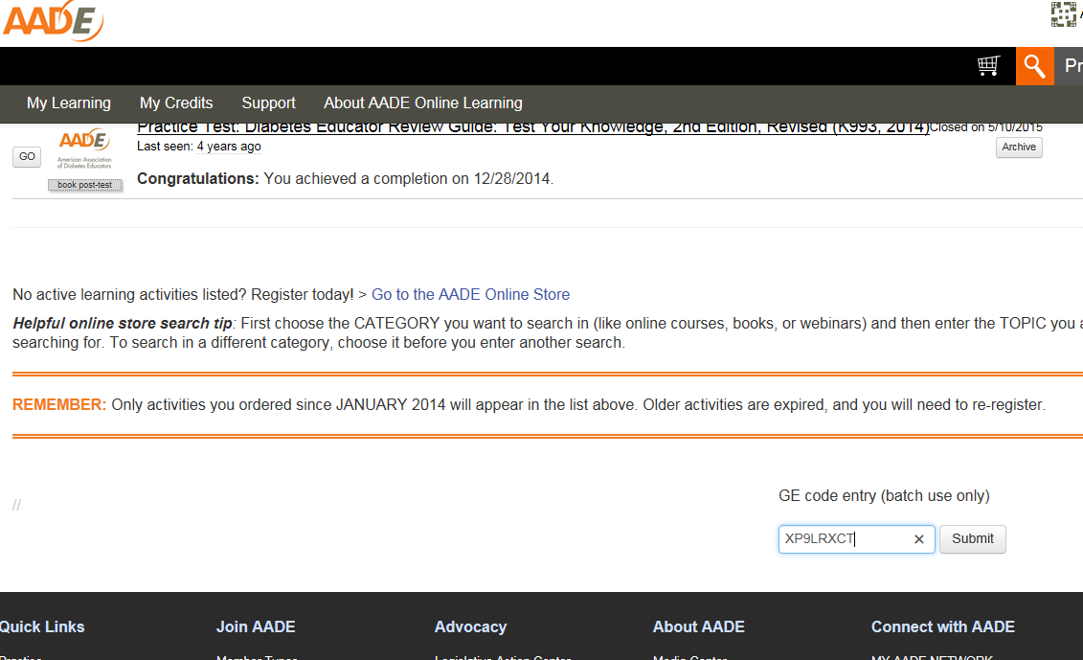
6

- Click “submit” to enter the learning activity, if necessary refresh the “My Online Learning” page, to see the webinar activity listed in your enrollments list.
- Click the title to begin

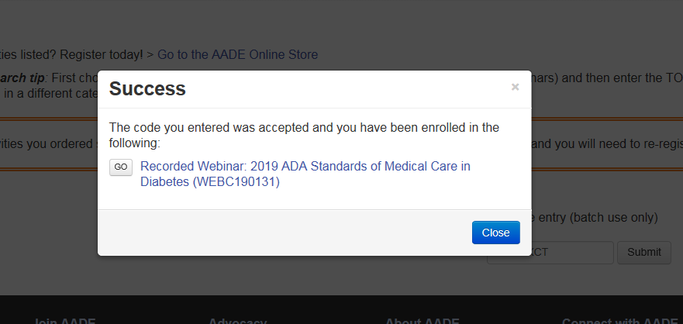
8

- Click in each of the items listed within the activity page. No need to download the PDF unless you want to.

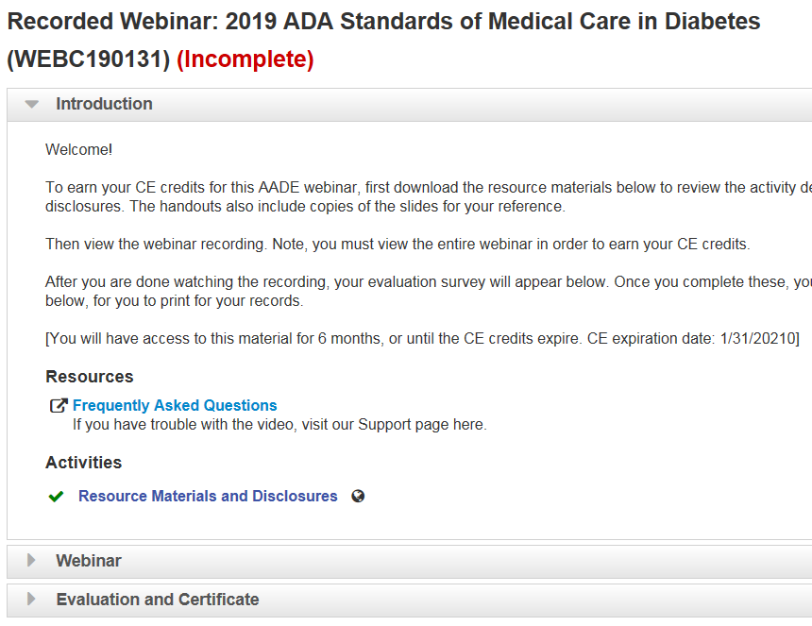
9

- Watch the webinar

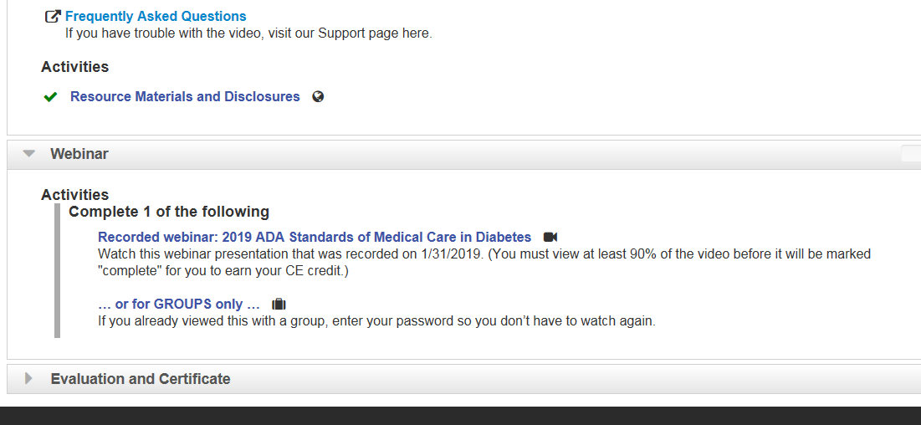
10

- Take any required quiz and the evaluation survey, to be able to access your CE statement of credit.

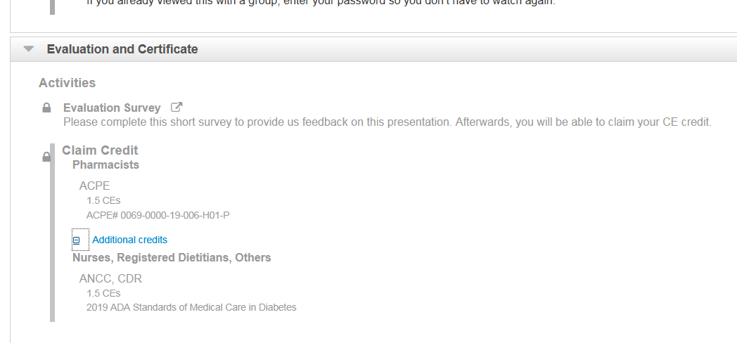
11

- You can return to your “My Learning” link at www.diabeteseducator.org whenever you want to access your learning activities (no need to use the GE code again).

